**CHAPTER 1**

**INTRODUCTION**

1. **Background**

Website and mobile application become vast developing in the world this recent day. The reason behind this trend is because many people want to access information as quickly as possible using their simple device, which they carry everyday. According to Flurry Analytic.com [15] store, 80% people spent their time in their IOS device to browse apps compare with the other 20% who only use their web browsers. In addition, since many social media are popping out in our society, people tends to want to socialize more as fast as they could, therefore there’s an increase for people using their phone for their daily basis.

Many store or business starting to create their own mobile application [2] or website. This statement has reasons to stand because firstly, it is a convenient way to interact with users. By installing the application, user can get all the information that needed and keeping update with the vendors. Secondly, it helps the company to use the apps as their promotional tool. The company wants to target as many costumer as they want, in the past many company use the old fashion way of how company promote their product such as putting advertisement in the magazine, creating a brochure, television advertisement, and many more. Comparing with a mobile application, the company just simply needs to pay the cost for developing mobile phone application and the user can download the application. Therefore we can conclude that the company will have less expense for paying the monthly advertisement comparing just to create one time application. Last but not least reason is compete with other companies.

According to Ashdown [1], Daniel a reporter from Juniper Research found that the revenue from mobile search and founding would reach approximately 15 billion US dollar, increasing three times from the year 2012. Which lead to a new real estate opportunity for the advertiser. Moreover, the report also discovers that the highest of the mobile advertising is on the cost per click, web search, local search, augmented reality search and discovery apps. Since it help the advertiser accurately targeted their costumer.

The problems, which occur during this trend is there is no connection between each business based on their location based. For example is Foursquare application. According to Foursquare:

*“Foursquare is a free app that helps you and your friends make the most of where you are. When you're out and about, use Foursquare to share and save the places you visit. And, when you're looking for inspiration for what to do next, we'll give you personalized recommendations and deals based on where you, your friends, and people with your tastes have been. “*

Foursquare give the user ability to check in to a place and give a recommendation about happening in that place recently. Most of the location-based check in application only limit their user check in and share their location with their friends. The costumer does not have enough information to that place; some of places have information only if other costumers give it to the certain location.

Other problems that occur in Jakarta are there is a lot of discount application (website and mobile application) that gives a lot of deals towards Jakarta’s people community. However the business flow of the deals giver seems flawed. For example, Samsung Galaxy Gift who gives free items daily to its user failed to target a costumer who doesn’t live near the shop location. This condition will give company disadvantage regarding reaching their costumers

Moreover, the connection between the same companies in different place is quite hard to maintain. For instance, there are two different Starbucks, which located in different location. Managing promotion or information for each store is quite a bump since they have to update to their main application and people who already in that place will miss that offer. By creating a mobile application that give important the information that user need to know before they check in to that place will give more advantages comparing just a simple dull check in application.

1. **Scope**

This research will work on mobile application, which will integrate on the prototype on IOS or Android mobile application. In addition, this application will support Indonesia/English languages and only targeted for Jakarta Region. This application will have the following core function:

User Application:

• Browse (Categories, deals, items, location)

• Check in to a specific location

• Browse and comment on top items

• Get Visit Coins

The brief description that mention it above is to create a mobile application that used a location based which will let the user browse the application based on the user needs such as location, items, promo, etc. In addition, when users already come to the store that listed on StoreIn database then user is able to perform check in to see additional discount for that user. Moreover, users are able to see what specialty or top items in that store. If the user use or bought something from the store then the user are credited the visit points from that store. For the business side, there will be done on website server which let the vendor update their items and promos.

1. **Aims and Benefits**

The aim of this project is to create a better mobile application for people to use for check-in based location and finds a good recommendation item in a certain place. This project will also bring several benefits towards several parties which is

• Helping people to find detailed information about what a location offer to them

• Connecting more people who share the same interest to the specific location

• Increase the relationship between business to user

• Increasing the number of loyalty costumer to the business side

1. **Structures**

**Chapter 1** This chapter will discuss about background, scope, aims and benefits and structure for this thesis

**Chapter 2** This chapter will discuss and explain the terminology which will be used when creating this thesis, which include the theoretical foundation and theoretical framework

**Chapter 3** This chapter will explain about the existing problem, existing solution, analyze the existing solution and explaining the purposed solution.

**Chapter 4** This chapter describes the design of the system as a whole, as well as the classifier.

**Chapter 5** This chapter presents how the testing was conducted, testing results, and how the solution will be implemented.

**Chapter 6** This chapter analyzes and evaluates the testing results presented in Chapter 5.

**Chapter 7** This chapter concludes the thesis and discusses possible future works on the solution.

**CHAPTER 2**

**THEORITICAL FOUNDATION**

For this section most of the terminology that will be included are developing environment, programming terms, and the location based system theory

* 1. **Developing Environment**

**In this section, the author defines the choices of development environments that might be used for developing this application. There are two type of how application can be developed, which are cross platform and native environment.**

* + 1. **Cross Platform Environment**

Developing a mobile application can be deployed to several systems such as Android, IOS, Windows Phone, and etc. Each of it system has it own native language to program the application. Android using Java language and Eclipse as it development tool while IOS use Objective C and X-Code. However, in this recent day there is a lot of cross platform development tool created for developer. One of them is Appcelerator. According to Appcelerator.com [9],

*“Today companies must offer great apps that run on a range of devices, and connect to an exploding set of backend data. Appcelerator solves for this new mobile reality: delivering native cross-platform apps at the speed of web, mobilizing any data source, and driving success with real-time analytics – all from an open, cloud-based platform: “*

Appcelerator offer a great numerous features that help finishing the thesis. Firstly, it gives the ability to create a cross platform application. Secondly, developing mobile application in Appcelerator use JavaScript language then it will be converted to its own platform native language. Finally, it provides the developer with MVC alloy, which gives developer an easy use for the development studio.

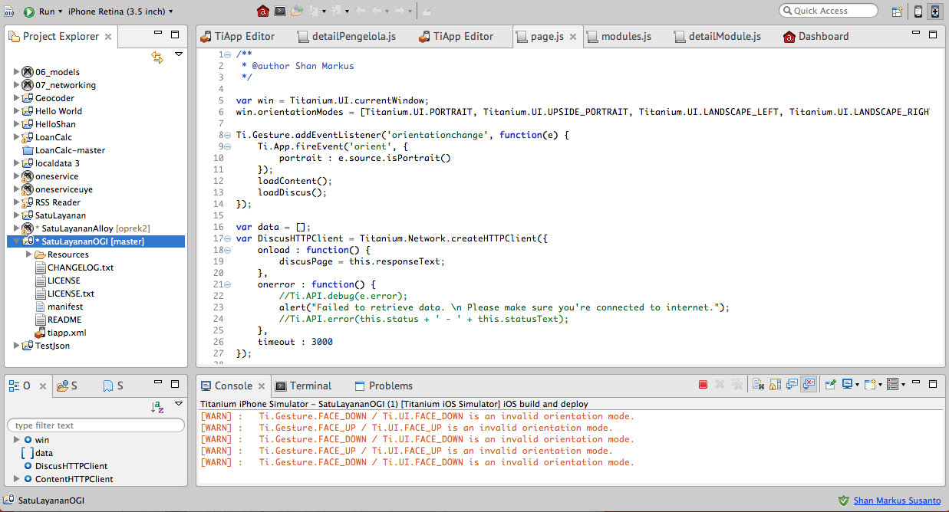

* + 1. **Android**

Android is an operating system that developed by Open Handset Alliance and promoted by Google. As software, android has the capability of targeting which hardware they want to put. Therefore, in this recent day we see so many smartphone adapt android as it native operating system. According to Marko Gagenta, Android is a good technology choices for several reasons;

1. **Comprehensive**

As for developers, Android gives all tools including the developing studio (Eclipse) and all the developing tools such as Android Development Bridge, which make developer easier to create a mobile application. In addition, Android development tool also provide us with simulator, which give access to developer who does not have testing device.

1. **Open Sourced**

Android is totally an open sourced development system, from the low level such as kernel level to the higher level such as user interface and database system. Android use Apache/MIT so other user can develop it for free. In conclusion, Android offer a totally free development items so developer can use it freely.

1. **Designed for Mobile Platform**

Android is for mobile platform. Simply because it was design as a tool for developing in mobile platform which has small screen size, and limited battery power. This factor has been considered by Android so when developer create a mobile application. This constraint wont limb the application.

After consideration of which development environment to use, the author decided to choose Android development tools for several reasons. The first reason is because the principal of going native is better than cross platform. To support this statement, the author has do some project based on Appcelerator environment tools which, creating an information application from a website. While doing this programming the author found several function that available in the native function but not available in the cross platform environment. Therefore, the author chooses for going native programming rather that using cross platform devices.

Secondly, by observing the trends of programmer to develop the application by each environment. According to StackOverflow.com data in 12th May 2014, there are a total of 507344 tags question about android, compare with Appcelerator, which only has 1246 questions. By observing this huge gaps difference between the user of Appcelerator and Android, the author choose Android as the main development tool for developing this application.

Finally, the reason for choosing android is because the ease access for using the extra plugins around the tools. For example, Google Maps , Cloud, and sync based feature, . Since Android is based on Google, therefore the access of the feature is more accessible comparing with other application.

* 1. **Location Based System**

Location Based System (LBS) is a system that is dependent on the location on the user. Which basically have two main actions, which are obtaining user position and utilizing the information from the user to provide a service to the user.

LBS has two different requested type for utilizing the information from the user which are [8]:

1. Push: The location retrieved when condition in set advance is fulfilled for example when the user enter the cloth shop then the service will automatically send to the user phone

2. Pull: When the user requested the service (nearby position application)

Push service will cost more since we using SMS or email method to send the service and it always update whenever the user location is. The advantage for the pull service is the user will not feel disturb while receiving the message or the input. Since user need to do something in order to receive the input such as press a button or check in, therefore the user are capable for choosing which time they feel comfortable when getting the input. On the other hand, push service is also having advantage and disadvantage for the user. One of the advantage example is user will get real time inputs regarding their location, while the disadvantage for this type of services is the user are not able to control the flow for the input that coming to them, which make some user feel uncomfortable using this push service.

In the author thesis, the author considered to use both of this technique to offer deals to the user, First, the pull technique will be used by the user to check their local deal. The scenario is when a user go to their favorite coffee shops, then the user will check-in to the specific coffee shop then the information about the place, deals, and top items will be sent to the user phone. Push service will be used to attract the costumer to go to the location that has the deal.

Location Based System has various ways to operate. Analyst and Researcher discover that LBS Services can be distinct to 2 types:

1. Person Oriented LBS, which the service will be based on person location (for example Friend Finder)

2. Device Oriented LBS, which based on the device location (Car Tracker)

The use for each type is clear by it definition, the person oriented is used when the target of the LBS is the user itself, the LBS is fully functional when it able to detect where is the user location and utilize it to a services such as friend finder or search nearby restaurant. While device oriented is based on the device or an item such as car. The example for this type is the application such as where is my iPhone application. According to this type classification, StoreIn will use Person Oriented type since it will locate where the user location then use it to give the list of deals and services.

Location Based System Methodology has been developed by time to time for finding the closest user position. The most common technology for LBS in this recent day are:

1. Cell Triangulation: using cell tower such as Telkomsel cell tower to calculating the position of the user. The more cell tower in one location the more accurate the system can predict where the user location (Disadvantage is it only good in a city not the rural area)

2. GPS (Global Positioning System) Use satellite to find the location. GPS is using trilateration to calculate the user’s position. Trilateration result can be found by calculating the speed, position, and elevation of the user. Currently there are 31 satellites orbiting the earth, which controlled by the US Departments of Defense.

3. Wi-Fi Hotspot detection has become a popular method for detecting user location since used by iPhone 2G. The Wi-Fi positioning using radio frequency 802.11 and try to connect to the nearest router to calculate distance.

After considering the advantages and disadvantages for each technology, the best way to locate the user position is by using each of technology. This type of approach called the hybrid technology. This technology is common used by mobile application because it capability to detect the user more accurate comparing to the other technology. For instance, The GPS will well functional if the user has the coverage of data service in their phone, however when the phone are unable to transfer and receive data then the device wont be able to get the user location. Comparing to hybrid position, if the GPS is not function then it will switch to other technology such as Cell Triangulation or even Wi-Fi hotspot detection.

* 1. **Social Media**

According to Oxford Dictionary [11], Social Media can be defined as “websites and applications that enable users to create and share content or to participate in social networking.” In this recent day, social media has become more than ordinary social media. Since it enable each user to share and create content, therefore business start acting as the user and post their items towards their community. Below is the example of social media that has integrated to business application

* + 1. **Facebook**

Facebook is a social media that let the user write their status, adding friends, check-in to certain location, post photos, and many other social activity. It start developed by Mark Zuckerberg in 2004 and starting its debut on the Harvard University by letting other user add their college friends. It keeps growing until now [13]. Facebook has become one of the top choice for user to sell their items, first they create account as the normally user do, then they starting to add friends or in this case as their potential costumer. Some user also create a fan page to attract more costumer to buy their item.

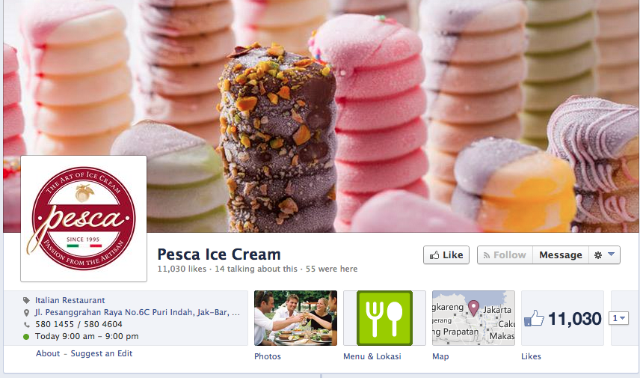

* + 1. **Instagram**

Instagram, is an online photo-sharing, video-sharing and one of the most popular social networking service especially in mobile application. It provides free custom designed filters that allows user to retouch the picture before publishing it to public. Instagram also give user capability to put their location towards their photo, so the user can map their photo to the map. In this day, instagram become the most active user in the social media according to the article that appear in the Tech Crunch [6].

* + 1. **Foursquare**

Foursquare is a social media application[12], which used check-in as it main feature to the users. It has a badge feature that will give to user for a certain action such as check in to crowded places or go to different malls. The application also gives a information about the nearby deals around user location.

After considering which social media is the best social media to be adapted to the thesis. The author chooses Facebook as the fittest social media sharing and Foursquare as the core system of the application works. In addition, by implementing several systems such as promotion gift away and top item list to give the user recommendation of what items they should buy in that place.

* 1. **Cloud**

According to Peter Mell and Timothy Grance, the definition is cloud computing is a model in computing which omnipresent, comfortable, appealing to give an ease access on computing resources (i.e, storage, data, applications, services). In addition, cloud computing also need to have the quick access to be managed and accessed during the interactions between users and servers. In the theory, cloud computing is based on five essential characteristics, three service models and four deployment models which are:

Essential characteristics:

1. On demand self services

Cloud computing have to have the capability for independent computing system. The service has to be automatically functioned without having other people or user available for interact with it.

1. Broad network access

It also needs capabilities to be accessed in broad network by using standard mechanism. The service has to be accessible for the thick and thin clients

1. Resource Pooling

The resource is invisible towards the client, in distributed system must be invisible to the clients. Which give the client a small knowledge about the place of the data and the service.

1. Rapid Elasticity

The service has to be capable for expanding or downgrading during the process of services.

1. Measured Service

While cloud computing gives these essential feature to the way for data to be served, cloud computing also need to has the essential indigents for calculating the data that send to the storage center. The data include the number of the user using the resources, calculating the bandwidth towards request and access during the services is done, and other features

Service models:

1. Software as a Services (SaaS)

This service models mostly used on the on-demand software which the user do not need to concern about the installation, setup, and launching the application. The service will manage those things to the user. The example of this service is Google Apps and Microsoft Office 365.

1. Platform as a Services (PaaS)

In this type of services, the services provide the user a platform which include programming language executing tools, operating system, database, setup progress, servers, and many more. Examples of this service include: Windows Azure, Heroku, Google App Engine.

1. Infrastructure as a Services (IaaS)

IaaS provide almost all of type of service that user needs, this service gives client greater control for managing their data in cloud computing. In addition, IaaS give client the ability for creating a virtual disk library, block and file storage, firewalls, and many more. Examples of these services are Amazone EC2, Windows Azure, and Google Compute Engine.

Deployment models:

1. Private Cloud

As it defined by its name, private cloud is only accessible to one or several business owner.

1. Community Cloud

This type of cloud deployment is based on community who shares the same interest during one system. Usually the cloud was managed by one or more organizations in the community or a third party.

1. Public Cloud

Public cloud is accessible towards public. The public cloud usually managed by government, academics, or a non-profitable organization.

1. Hybird Cloud

This type of cloud is a combination of private and public cloud. That has unique entity but bound to several rule and agreement between each infrastructures.

* + 1. **Windows Azure**

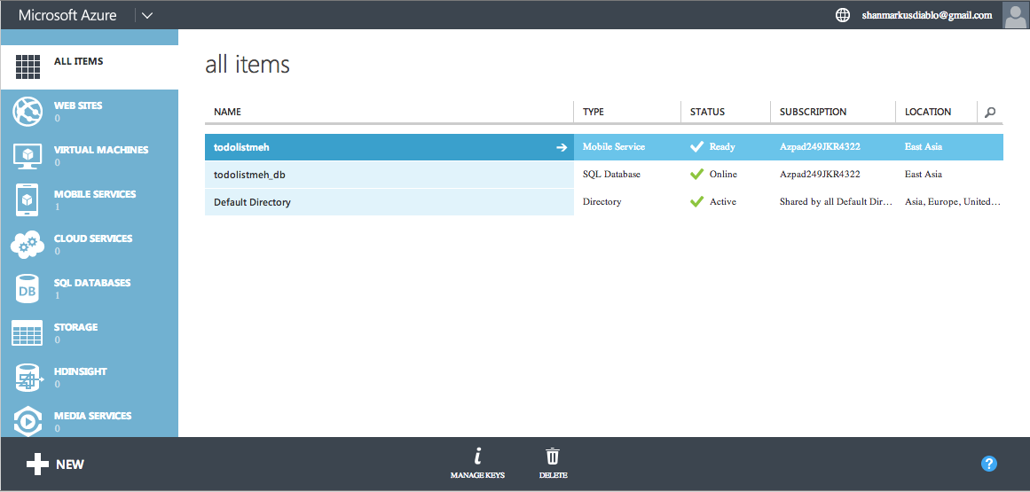

Windows Azure is an IaaS cloud models computing like it described above. According to Windows Azure, Azure is a Microsoft managed data centers that let the user deploy and maintain their data. In addition, Microsoft Azure let the client integrate their cloud application with their favorite developing environment. Azure guarantee that their server is going up for 99.95%, which gives a quite accessibility towards clients.

* + 1. **Parse**

According to Parse.com, parse is a cloud platform that let the client create beautiful apps without worrying about the complex infrastructure as IaaS (Windows Azure). In brief, parse give a capability for client to deploy an application that basically uses database, push notification, and cloud data in their application. In conclusion, Parse is an Software as a Service model of cloud computing which let the user create the database without fearing the complex procedure in maintaining the data.

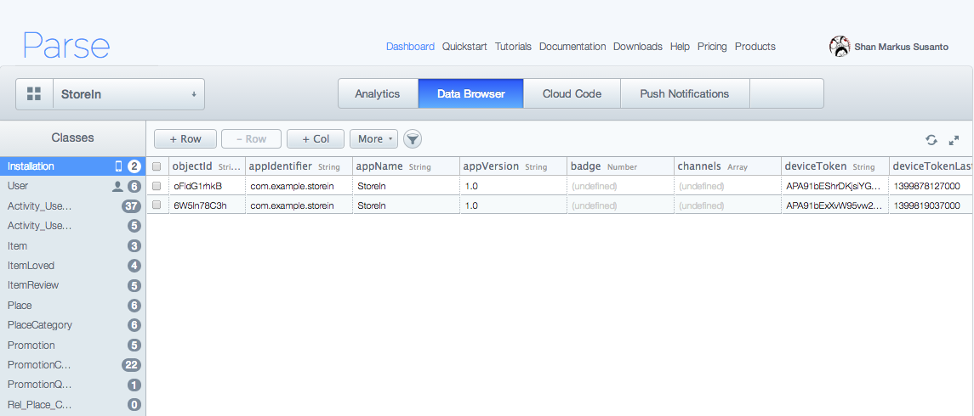

By comparing these two clouds computing methods. The author chooses Parse for several apprehensions. First, since the author will create an Android Application therefore better to choose the SaaS model which give less complex system to maintaining the data comparing with the IaaS method that Windows Azure gives. Secondly, Azure gives a good programming backend to maintaining how the data be collected each time a user do some query. Comparing with Windows Azure that required a quite amount of code to manage between the Sync and Async task. Finally, Parse is already bought buy Facebook for 83 millions, which gives the author ease access in order to integrate the application to social media (i.e Facebook).

* 1. Research Methodology

This research will be completed by several research methodologies:

1. Defining the current problems
2. Analyzing the existing solution which include Facebook, Instagram, Samsung Galaxy Gift, and Foursquare
3. Preparing some books or research paper about the project
4. Performing the distilled solution for what the user expect and will see with this outcome
5. Designing the system flow

* Determining the target API
* Determining the flow of the activity
* Calculating the relation between database
* Selecting the best algorithm to find the value for item and places
* User interactions
* Designing the application Logo and Icons

1. Designing the business flow for the application

* Creating the business flow for user application
* Creating the business flow for business application

1. Testing the solution
2. Evaluating the solution

**CHAPTER 3**

**PROBLEM ANALYSIS**

* 1. **Existing Problem**

An innovation comes on the *year 1980s* where a U.S Departement of Defense gives access towards the GPS (Global Positioning System) to the public. This gives many services (emergency, public, even commercial company) to get information surround them so they can get easily access what they need to do. Location Based System (LBS) has proven become a system that coefficient with other developing system. In this recent day, places become a significant point of interest for people to explore and do amazing things such as find nearest store or give location to each other.

According to the study by TNS [7] Almost 19 percent of the world’s six billion users who use mobile phone are already using LBS and the number will increasing more than triple from this number in the future. Application such as maps and GPS are the most common use for LBS application, however the diverse action for LBS uses are increasing during the year of 2011 to 50 percent. One of the features that user love is check-in likes Foursquare, or Facebook. In addition, TNS also found that one from three people agree that they would like to get some amount of deals which offered by their nearby store location

LBS also has grown their as a tool for creating a connection between user to business. When a business wants to grow they need to let the user know where their position and what are they selling. In addition, a need for company to reach their costumer nears their location. However there still no satisfying application for business or user to reach their need and loyal costumer. A mobile application that based on item, provide location of the store, even gives a promotional features towards costumer around the store.

* 1. **Existing Solution**
     1. **Go To Store Directly**

How to get the list of coffee from your favorite coffee shop is by going to the store and read all the menus in it. In addition, when user arrives to the store, they will find a billboard about what offer the store have today or on some period of time. Then they will enter the store and buy their drink. Moreover, after the costumer finished their drink then they will write a comment in a piece of paper and give it to the manager for compliments or complaints.

This method is the straightest forward for costumer to find what business offer and give feedback towards their satisfaction for a item. However, there is a lack of user-to-user connection in this direct method. For example, finding the most favorite drinks in this coffee shop. Usually, the categorization of item and promotional depends for each shop. In this case, author chooses Starbucks for example of case. Starbucks shop has different location in every corner location in Jakarta (World) and some of it have different promotional feature regarding its place and time. For example, the Starbucks which locating in Jakarta has offer for upsize if the costumer use BCA Credit Card, while in USA this offer does not exist.

Regarding the item managements, the author observes items those Starbucks sales, which can classify into several categories. One of them is drink. Their Drinks is also have sub-classify into several categories such as espresso and coffee, Tea, Frappuccino, and chocolate. Costumer can select one of the items and purchase it.

The advantages from this solution is this method is simple and direct which create the minimum confusion between the vendor and the costumer regarding the item and promo they want to sell. In addition, the cost for using this solution is lesser comparing with other solution that author found.

The disadvantages for this solution is the costumer have to find the store first to get the item and promotional and the time spend for some costumer to go to the store directly is quite high.

* + 1. **Social Networking (Facebook and Instagram)**

Social Networking let user to create publicity in their profile page while let that person connect to other person. In this recent day, social networking has altered from mere social network to business application. Some users create a profile or page that sell item to their costumer. One example for this situation is Facebook and Instagram.

Facebook has one of LBS features in Facebook places, which let user check in to a certain location and share it to their friends. Facebook also become a place where user can sell their items towards their costumer through wall post and messages. Other user can follow or add friend to the business they want to follow, after they know what business they follow then people are able to like or follow updates from the business. While Instagram offer business to sell their item by posting photos and ability to follow their favorites vendors.

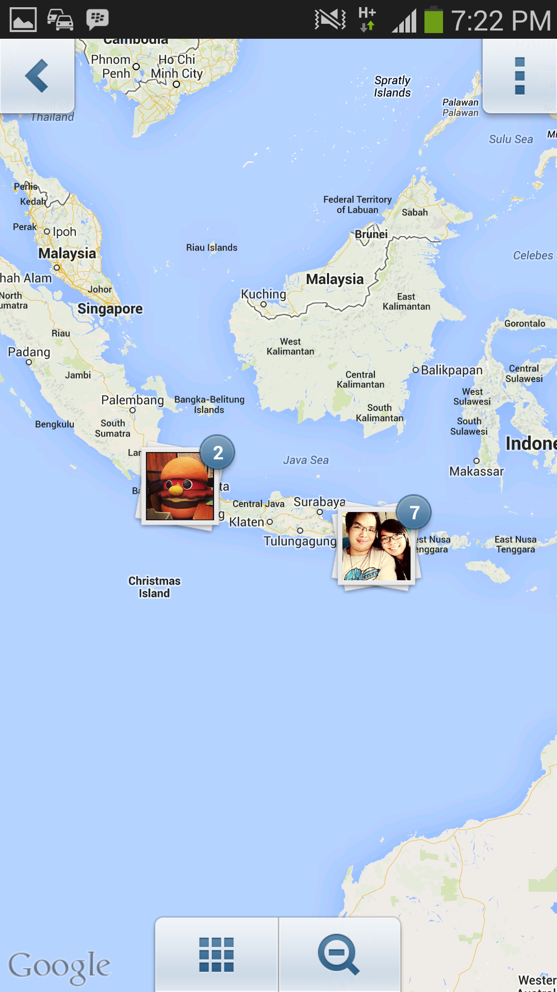

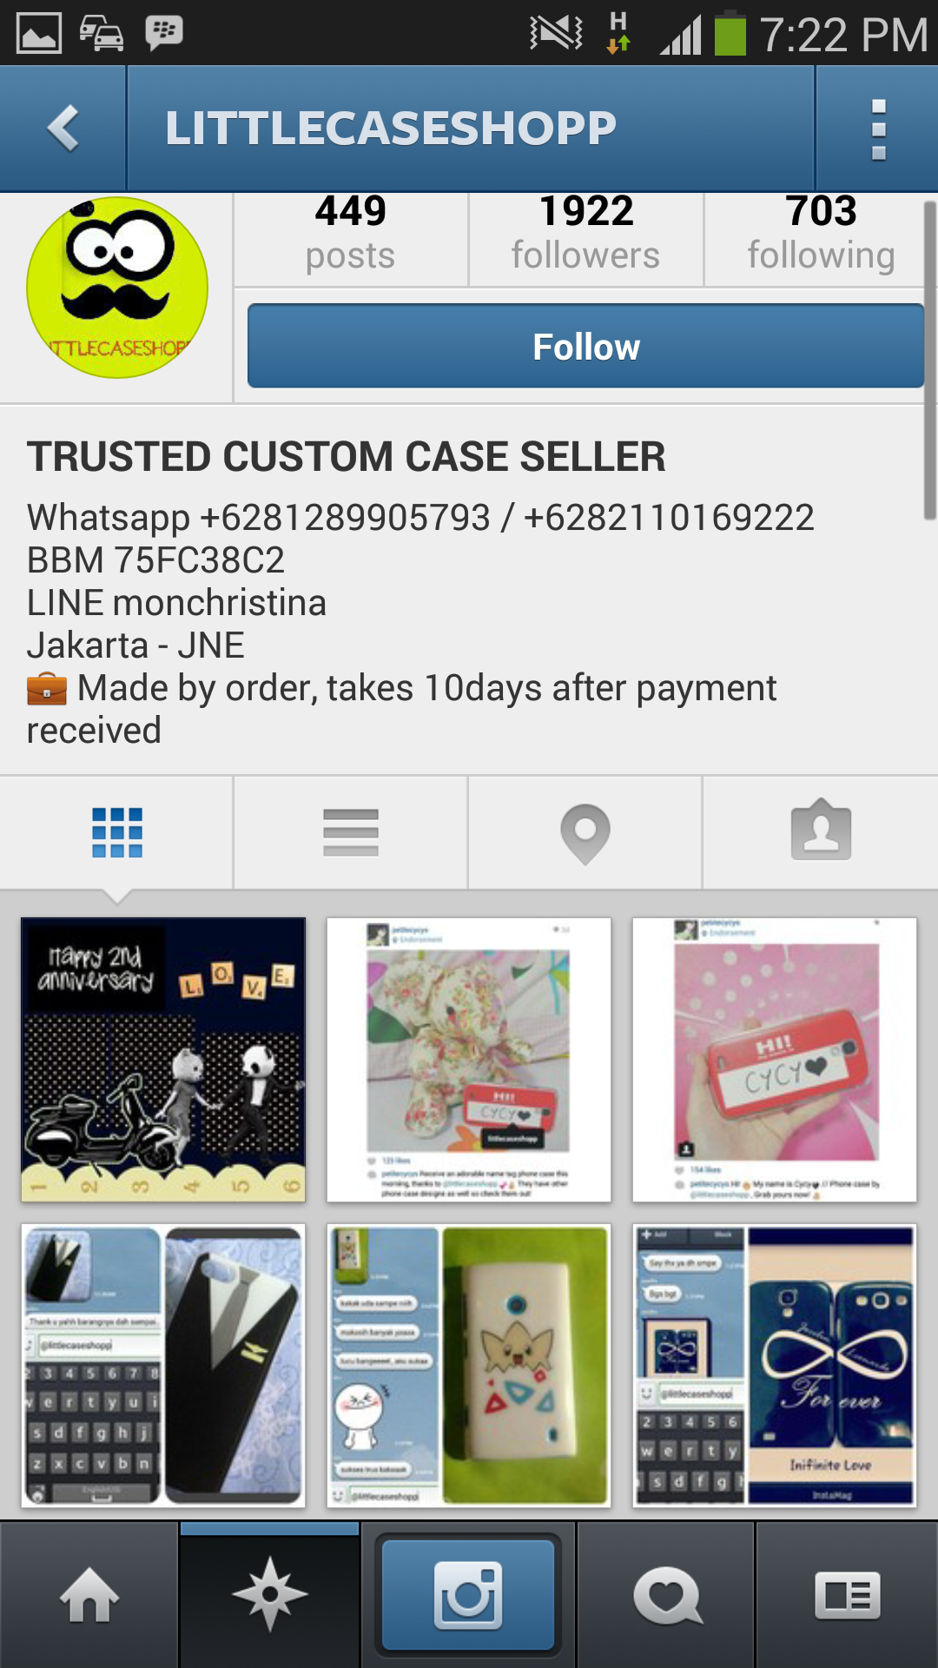

On one hand, these social media is a good place for creating a business page application since the purpose of social media is to connecting people so vendors and businesses will easily find user comparing with other solution that author found. Moreover, Instagram has a unique feature for hash tag, which let user to find the item easily. This application is available to almost device system such as Android, IOS, and other OS. Instagram for example has integrated system towards other social media such as Foursquare and Facebook.

On the other hand, some social media is not targeted as business application because it extends the function from social media application to a business application. For example Facebook, user wants to connect with their friends while getting update from the businesses they want to follow. However the result is mesh up when user open their timeline (homepage) since all the information is mixed up between user friend and their business feed. Moreover, maintaining loyalty costumer is quite hard since Facebook and Instagram does not know which costumer already been into that store or not

* + 1. **Promotional Application (Samsung Galaxy Gift)**

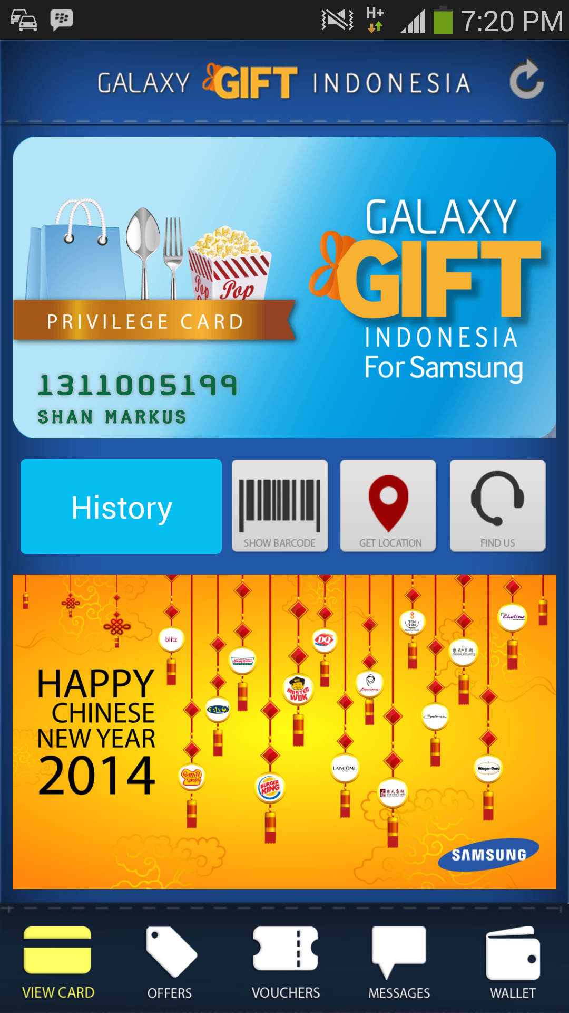

Sometimes, business industries try to use third party application to give promotion or offer to their loyal costumer. One of example of this condition is Samsung Galaxy Gift. Galaxy gift is a mobile application that gives promotional offers towards their costumer. Promotion will given daily by several vendors through this application, the promotion is based on tickets (quota). For instance, at 9:00 am Cha Time give 500 quotas for free premium regular drinks with free toping. The costumer then will have to open the application and claim the rewards before the other costumer claim it. Samsung Galaxy Gift also offer a membership card to a costumer who loyal to their vendor.

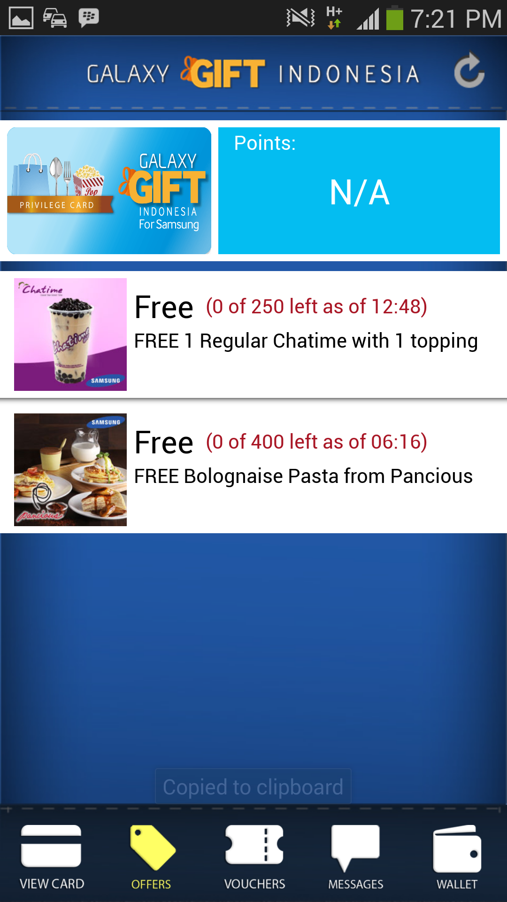

This application only available towards several Samsung type such as Samsung GALAXY Note 3, Samsung GALAXY S4, Samsung GALAXY S4 Mini, Samsung GALAXY S4 Zoom, Samsung GALAXY Mega 6.3, and Samsung GALAXY Mega 5.8. Which gives other phone user a let down since they cannot use this application. Moreover, the problem occurs when some people get their ticket but never claims it, which will reduce the rate of successful for promotion give. In addition, according to the survey only less than 30 percent uses the loyalty cards rewards and only 12 percent from the total user who used this application to find the nearby location of that store.

The advantages from this application are it creates connection between user and business so they can give promotion towards every user whenever they are. They also create a e membership card so it gives reward to user every time they purchase several times.

* + 1. **Foursquare**

Foursquare is an application which using Location Based System as it primary tool. As it define at foursquare.com [12], *“Foursquare is a free app that helps you and your friends make the most of where you are”* (foursquare.com, 2014), this application offer vary types of features. Check in system is one of feature that foursquare offer. This feature lets the user select the place and share their location to their friends. After the user finish doing check in, user also able to leave tips which contain their experience or comment about the place.

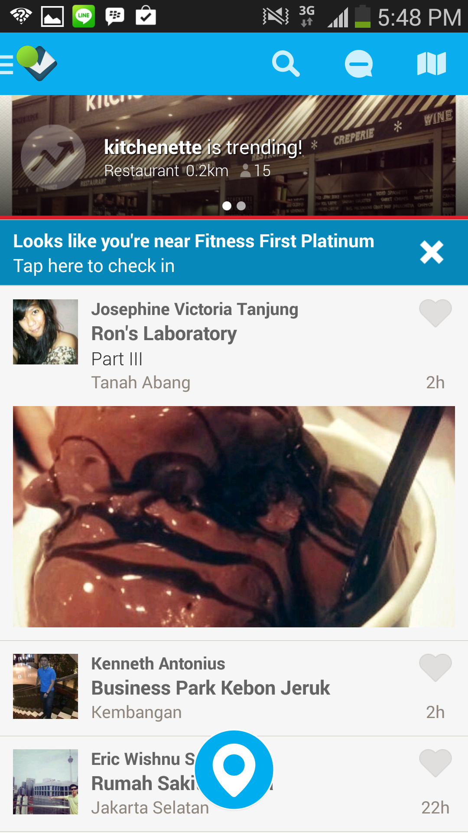

This application use push and pull notification for their services. The pull notification will launch when user perform the check in using foursquare which will give information about the place such as opening hours, rate of the place, etc. The push services will be launch randomly when user turn on Wi fi and GPS on their mobile application and asked the user do they want to check in to their nearby place. User also can get a deal from the place they visited.

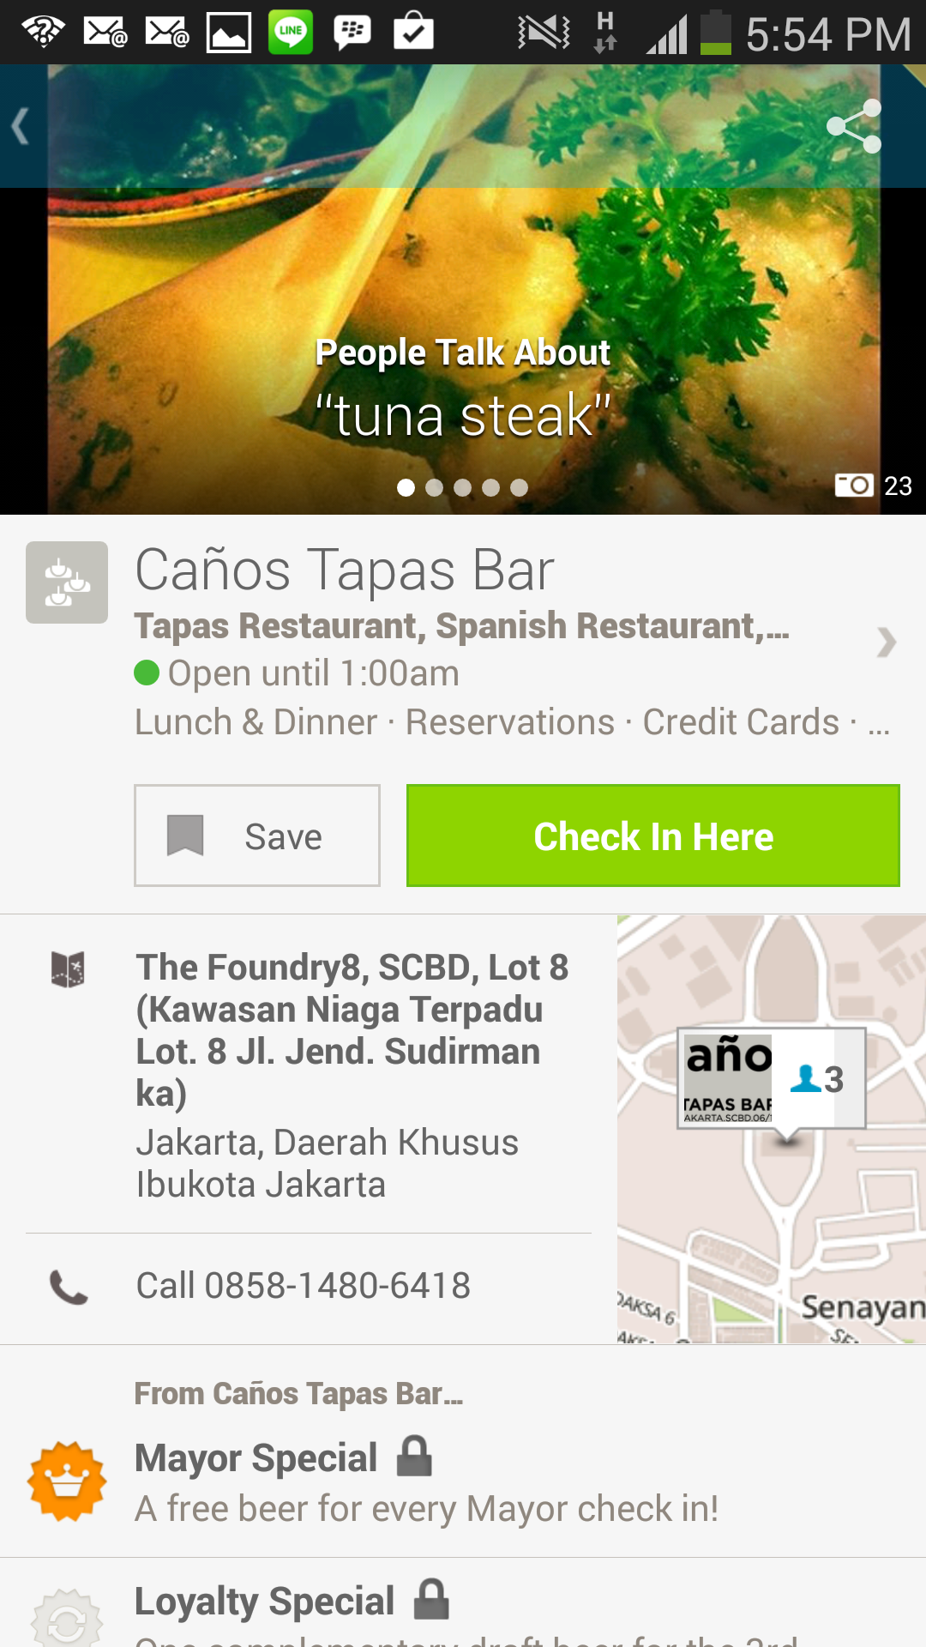

Below is the example of mayor and loyalty check in special deal. However, the problem with foursquare is the ambiguity between business application and social media. On one side, foursquare gives awesome features for user to share their location and experience for a place. On the others hand their business model still subtle (the ambiguity between social media and business application).

* 1. **Analysis of Existing Solution**

For every solution there will be advantages and disadvantages. To given explanation, author selects which criteria that should be compare, which are:

1. **Purpose**: Gives brief description of the uses of the social media

2. **Accessibility**: The type of system that the application applicable to

3. **Services**: Checks what kind of services the application has. In this criteria it will be divided into two type which is pull and push services

4. **Integration with other application**: Checks whether this application can be integrated towards other social media

5. **Features**: To find what unique features / traits that the application has comparing with other solutions

6. **Strengths**: These criteria define why this application is good for the existing problem and may be use for development

7. **Weakness**: These criteria define why this solution is making people hate to use it as the solution for the problem

Table 3.1 represents the existing solution comparison with the all aspect above.



Table 3.1 Comparison on existing application as business application

* 1. **Proposed Solution**

By observing the analysis above, it can be settled that there is a different way for each application to become business application, however each of solution that exist abovenot adequate enough**.** Go to store directly will give the precise information about the items or services or deals that the store offer but the cost of time for this solution is too high. Facebook and Instagram proven to be an effective way for user to communicate each other however, the uses of these applications as business application still fail to satisfy it core function as the social media, since it combine all the feed from the seller and their user friends. Samsung Galaxy Gift use different approach as business plan application that offer their user free deals everyday, however this approach fail to reach some of the costumer since it broadcast all the deal to all user. The Author purpose a solution which give the user an ability to browse, check-in, get the information about the place including the items, and rewards to the user as the rewards for their loyalty to the vendor. In addition, foursquare is the closest solution for this problem. However, the business flow for it still confuse user, the main purpose is still ambiguous, does Foursquare wants the user to use it for earning badge or finding store or sharing location or all.

**CHAPTER 4**

**SYSTEM DESIGN**

* 1. **Preliminary Survey**

The author has given the preliminary survey in order to get the basic understanding of what application that author should create in this research project.

There are 3 basic demographics question, which contain the age, gender, and current job for the participants. The survey showed that 77% of the respondents is male while the other 23% is female respondents. In addition, the age of respondents average is around 14 – 25 years old. The results also display the significant number for respondents who still doing their undergraduate study in university. However, there are 20% respondents that work as employee in their daily life.

* 1. **System Architecture**

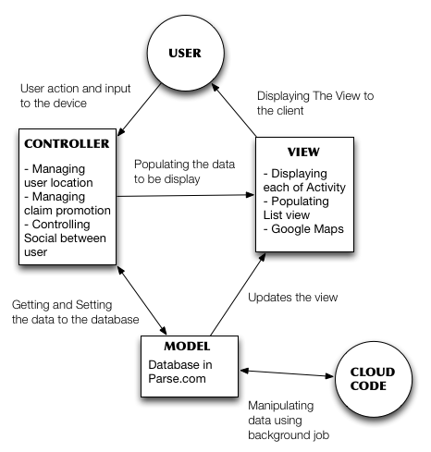

**Figure 4.2 System Architecture Diagram**

Diagram that shown below represent the architecture that StoreIn use, which in this case is Model View Controller (MVC) system architecture. MVC has been around in the software development technology since 70’s, which found by a Professor who lives at Oslo named Trygve Reenskaug (C2.com). The purpose of this system architecture is to define a clear representation of what user will see, what the program will do, and how the data being handle. However, the author adds an extra entity other that user which is Cloud Data, which will be, explain later.

In Figure 4.1 it depict the system architecture of StoreIn and how each of it entity interact with each other during the process of work.

* **User**

User in this case is a person that uses StoreIn application. Since StoreIn is a Business to Client application therefore it has two different types of user, which also use two type of application regarding their interaction towards model. For example, a user that acts as a customer will use StoreIn application to check in and claim promotion that will lead to data manipulation in the system. However, the other user who act as the business side of the application will use StoreIn Business to approve the customer claim and also lead to manipulating the data in the system.

* **Controller**

Controller act as the connection between user and model in MVC architecture by facilitate the input or change and manipulating the input towards the database or the model in StoreIn. In the author application there are a lots of controller type that been used, from a simple getting the user input and save it to the database (edit a data) to calculating the place nearby the user and claiming a promotion.

* **Model**

Model represents an object that being used in StoreIn Application. Like the usual explanation about object in Object Oriented Programming, object represents an entity that has a state and function in the application. An object usually has a setter and getter function in order to manage their variable and a method, which explain what the object can do.

* **View**

View is the visual representation of what user will see in their device. Since the author use Android as it development environment then most of the view is written in Extra Markup Language (XML). Inside the Android Development Tool, there are several widget that can be used in order to create this application such as Edit Text, Text view, and many more. The author also implements Google Maps to detect where the user last location and to give list of promotion in the user surroundings.

* **Cloud Data**

In this system architecture the author add a Cloud Data as extra entity for the system architecture. Cloud Data is extension that Parse give to the user to maintaining the background jobs that relating to database. For example, in StoreIn there are a database model that holds the number of total check in for each user whenever the user check in to several places. Rather that put the code into the user device (Client base) the code will be run simultaneously in the parse as the Cloud Data. So whenever user checks in to a place then the Cloud Data will run asynchronously.

* 1. **User Requirement**

User requirement will explain the basic diagram such as Use Case Diagram.

* + 1. **Use Case Diagram**

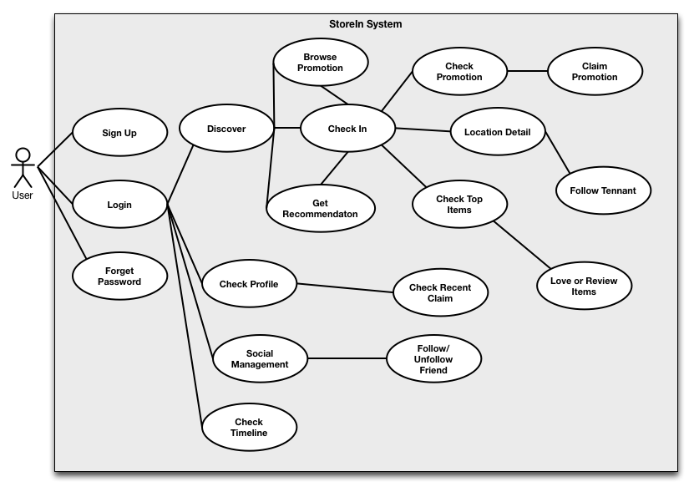

**Figure 4.3 Use Case Diagram of StoreIn**

This diagram represents what user can do in the StoreIn application which represent in use case diagram.

* + - 1. **Login**

When user firstly use StoreIn then the user have to login first in order to retrieve their current profile and related data such as total check in, recent promotion, and many more. StoreIn also give a user choice to login using Facebook to make the login flow become easier.

* + - 1. **Sign Up**

If the user has not registered to StoreIn application, then the user need to register their information such as their name, email, and password. After user finished with the sign up process then the user can start to use the application straight away.

* + - 1. **Forget Password**

User can retrieve their lost password by using this function. The password will be sent after the user finished filling the email field in the forgot password use case.

* + - 1. **Discover**

When user firstly finished the login application, then the user will be redirected to Discover page. In this page user will able to browse promotion, check in to several place, and get recommendation.

* + - * 1. **Browse Promotion**

User is able to browse promotion accordingly to the category. After user finish selecting the promotion they want to get, then the user has to check in to the location that has the promotion.

* + - * 1. **Check In**

User are given a list of place that nearby to the user. In addition, user can select the place they want to be and do the check in.

**Check Promotion**

User can check list of promotions that available inside that place

**Claim Promotion**

User can claim promotion

**Location Detail**

User can see the description of the place including the opening hour, ratings, and total user check in to that place

**Check Top Items**

User can check the list of top items that the store offers.

**4.3.4.2.4.1 Review or Love Item**

User is able to love the item and review the item.

* + - * 1. **Get Recommendation**

User can get the recommendation promotion or place that nearby user location.

* + - 1. **Check Profile**

User is able to view their stat regarding user total check in, claimed promotion, number of follower and following user.

* + - * 1. **Check Recent Claim**

User can see their recent un-claimable activity. In addition user can claim the promotion by showing the code to the tenants to be approved.

* + - 1. **Social Management**

User is able to see their follower and find friend.

* + - * 1. **Follow and Un-follow Friend**

User are able to follow and un-follow friend and see their recent activity.

* + - 1. **Check Timeline**

User is able to see recent activity from other user that they followed.

* + 1. **Use Case Description** 
       1. **Login**

|  |  |  |
| --- | --- | --- |
| **Use-Case Name:** | Login | **Use Case Type**  **Business Requirements** |
| **Use-Case ID:** | USE-1 |
| **Priority:** | High |
| **Primary System Actor:** | User | |
| **Description:** | This use case describe how user can login to the system by providing username and password | |
| **Precondition:** | none | |
| **Trigger:** | Button click | |
| **Typical Course Of Events:** | **Actor Action** | **System Response** |
| Step 1: User clicks the LOGIN button | Step 2: System will navigate user to Main Activity |
| **Conclusion:** | This use case is use for login so the user are able to use StoreIn | |

* + - 1. **Forget Password**

|  |  |  |
| --- | --- | --- |
| **Use-Case Name:** | Sign Up | **Use Case Type**  **Business Requirements** |
| **Use-Case ID:** | USE-2 |
| **Priority:** | Low |
| **Primary System Actor:** | User | |
| **Description:** | This use case describe how user retrieve their password in case their forget their password | |
| **Precondition:** | None | |
| **Trigger:** | Button click | |
| **Typical Course Of Events:** | **Actor Action** | **System Response** |
| Step 1: User input the email address  Step 2 : User press forget password button | Step 3: System will send confirmation to the user email  Step 4: System will navigate user to Login Menu |
| **Conclusion:** | This use case conclude how user can get their password | |

* + - 1. **Sign Up**

|  |  |  |
| --- | --- | --- |
| **Use-Case Name:** | Sign Up | **Use Case Type**  **Business Requirements** |
| **Use-Case ID:** | USE-3 |
| **Priority:** | Low |
| **Primary System Actor:** | User | |
| **Description:** | This use case describe how user can sign up to StoreIn application | |
| **Precondition:** | None | |
| **Trigger:** | Button click | |
| **Typical Course Of Events:** | **Actor Action** | **System Response** |
| Step 1: User input the field that required such as emai address, username, name, and password  Step 2 : User press sign up button | Step 3: System will navigate user to main activity |
| **Conclusion:** | This use case conclude how user can sign up to StoreIn | |

* + - 1. **Discover**

|  |  |  |
| --- | --- | --- |
| **Use-Case Name:** | Sign Up | **Use Case Type**  **Business Requirements** |
| **Use-Case ID:** | USE-4 |
| **Priority:** | High |
| **Primary System Actor:** | User | |
| **Description:** | This use case describe how user location is and display the list of place that near the user location | |
| **Precondition:** | USE-1 | |
| **Trigger:** | none | |
| **Typical Course Of Events:** | **Actor Action** | **System Response** |
|  | Step 1: System will give the list of place that near user location |
| **Conclusion:** | This use case conclude how user can discover their surroundings | |

* + - 1. **Browse Promotion**

|  |  |  |
| --- | --- | --- |
| **Use-Case Name:** | Sign Up | **Use Case Type**  **Business Requirements** |
| **Use-Case ID:** | USE-5 |
| **Priority:** | Medium |
| **Primary System Actor:** | User | |
| **Description:** | This use case describe how user browse list of category in order to get the promotion that user wants | |
| **Precondition:** | USE-4 | |
| **Trigger:** | Button click | |
| **Typical Course Of Events:** | **Actor Action** | **System Response** |
| Step 1: User press the recomendattion button  Step 3: User will select the category | Step 2 : System will redirect to promotion page  Step 4: System will gives the list of promotions regarding that category |
| **Conclusion:** | This use case conclude how user can get spesific promotions by selecting the category. | |

* + - 1. **Get Recommendation**

|  |  |  |
| --- | --- | --- |
| **Use-Case Name:** | Get Recommendation | **Use Case Type**  **Business Requirements** |
| **Use-Case ID:** | USE-6 |
| **Priority:** | Medium |
| **Primary System Actor:** | User | |
| **Description:** | This use case describe how user can get recommendation from surroind them by location their position | |
| **Precondition:** | Use-4 | |
| **Trigger:** | Button click | |
| **Typical Course Of Events:** | **Actor Action** | **System Response** |
| Step 1: User press the recomendattion button | Step 2: System will gives the list of promotion or place |
| **Conclusion:** | This use case conclude how user can get their password | |

* + - 1. **Check In**

|  |  |  |
| --- | --- | --- |
| **Use-Case Name:** | Check In | **Use Case Type**  **Business Requirements** |
| **Use-Case ID:** | USE-7 |
| **Priority:** | High |
| **Primary System Actor:** | User | |
| **Description:** | This use case describe how user can check in to a place in order to get promotion, view location details, and location catalog | |
| **Precondition:** | Use-4 | |
| **Trigger:** | Button click | |
| **Typical Course Of Events:** | **Actor Action** | **System Response** |
| Step 1: User press the check in button  Step 3: User press the place that he/she want to check in | Step 2: System will gives the list of place that near the user  Step 3: System will redirect to location details and location catalog |
| **Conclusion:** | This use case conclude how user can check in to a certain location | |

* + - 1. **Check Promotion**

|  |  |  |
| --- | --- | --- |
| **Use-Case Name:** | Check Promotion | **Use Case Type**  **Business Requirements** |
| **Use-Case ID:** | USE-8 |
| **Priority:** | Medium |
| **Primary System Actor:** | User | |
| **Description:** | This use case describe how user can see the list of promotion that the place has offer | |
| **Precondition:** | USE-7 | |
| **Trigger:** | Button click | |
| **Typical Course Of Events:** | **Actor Action** | **System Response** |
| Step 2: User press the promotion that the user want to claim | Step 1: System will gives the list of promotion including the total reward for each promotion  Step 3: System will redirect to the Claim Promotion Page |
| **Conclusion:** | This use case conclude how user can see the list of promotion that that place offer to the user. | |

* + - 1. **Location Detail**

|  |  |  |
| --- | --- | --- |
| **Use-Case Name:** | Check Promotion | **Use Case Type**  **Business Requirements** |
| **Use-Case ID:** | USE-9 |
| **Priority:** | Low |
| **Primary System Actor:** | User | |
| **Description:** | This use case describe how user can see the detail of place that the user has been check in to. | |
| **Precondition:** | USE-7 | |
| **Trigger:** | Button Clicked | |
| **Typical Course Of Events:** | **Actor Action** | **System Response** |
|  | Step 1: System will gives the list detail of place including phone number, opening hour and etc |
| **Conclusion:** | This use case conclude how user can see the detail of a location where user has been check in to. | |

* + - 1. **Check Top Items**

|  |  |  |
| --- | --- | --- |
| **Use-Case Name:** | Check Top Items | **Use Case Type**  **Business Requirements** |
| **Use-Case ID:** | USE-10 |
| **Priority:** | Medium |
| **Primary System Actor:** | User | |
| **Description:** | This use case describe how user can see the list of popular items that the store or place putted to the application | |
| **Precondition:** | USE-7 | |
| **Trigger:** | Button click | |
| **Typical Course Of Events:** | **Actor Action** | **System Response** |
| Step 2: User clicked the item they want to see | Step 1: System will gives the list of items which include the total of loved from other users  Step 3: System will redirect the user to Loved and Review item page |
| **Conclusion:** | This use case conclude how user can see the list of items that place offer to the user. | |

* + - 1. **Claim Promotion**

|  |  |  |
| --- | --- | --- |
| **Use-Case Name:** | Claim Promotion | **Use Case Type**  **Business Requirements** |
| **Use-Case ID:** | USE-11 |
| **Priority:** | High |
| **Primary System Actor:** | User | |
| **Description:** | This use case describe how user can claim the promotion within a location | |
| **Precondition:** | USE-8 | |
| **Trigger:** | Button click | |
| **Typical Course Of Events:** | **Actor Action** | **System Response** |
| Step 1: User press the claim button | Step 2: System will gives code of approval for the user to show it to the tenant |
| **Conclusion:** | This use case conclude how user can claim a promotion in one place. | |

* + - 1. **Follow Tenant**

|  |  |  |
| --- | --- | --- |
| **Use-Case Name:** | Follow Tenant | **Use Case Type**  **Business Requirements** |
| **Use-Case ID:** | USE-12 |
| **Priority:** | Medium |
| **Primary System Actor:** | User | |
| **Description:** | This use case describe how user can follow the tenant to recieve an updates (Push Message) from each tenant that user follow | |
| **Precondition:** | USE-9 | |
| **Trigger:** | Button click | |
| **Typical Course Of Events:** | **Actor Action** | **System Response** |
| Step 1: User press the follow tenant | Step 2: System will save the user preference regarding the tenant choice |
| **Conclusion:** | This use case conclude how user can follow the tenant to recieve further updates from the selected tenants. | |

* + - 1. **Love or Review Item**

|  |  |  |
| --- | --- | --- |
| **Use-Case Name:** | Love or Review Item | **Use Case Type**  **Business Requirements** |
| **Use-Case ID:** | USE-13 |
| **Priority:** | Low |
| **Primary System Actor:** | User | |
| **Description:** | This use case describe how user love and review item. In addition, user also can see the description of the item | |
| **Precondition:** | USE-10 | |
| **Trigger:** | Button click | |
| **Typical Course Of Events:** | **Actor Action** | **System Response** |
| Step 1a: User press the love button  Sep 1b: User press the review item | Step 2: System will show the item description  Step 2b: System will redirect to the review item activity |
| **Conclusion:** | This use case conclude how user can love and review item. | |

* + - 1. **Check Profile**

|  |  |  |
| --- | --- | --- |
| **Use-Case Name:** | Check Profile | **Use Case Type**  **Business Requirements** |
| **Use-Case ID:** | USE-14 |
| **Priority:** | Medium |
| **Primary System Actor:** | User | |
| **Description:** | This use case describe how user can see their stat regarding total of check in, total of follower, total of following and total claimed promotion | |
| **Precondition:** | USE-1 | |
| **Trigger:** | Button click | |
| **Typical Course Of Events:** | **Actor Action** | **System Response** |
| Step 1: User press the Homepage | Step 2: System will give the stat about the total check in, claimed promotion, etc |
| **Conclusion:** | This use case conclude how user see their track record regarding the total check in, claimed promotion, number of follower and following. | |

* + - 1. **Check Recent Claim**

|  |  |  |
| --- | --- | --- |
| **Use-Case Name:** | Check Recent Claim | **Use Case Type**  **Business Requirements** |
| **Use-Case ID:** | USE-15 |
| **Priority:** | Medium |
| **Primary System Actor:** | User | |
| **Description:** | This use case describe how user can see their recent claim promotion activity. User can see their un-claimable promotion and claim it by showing the claim activity ID to the involved tenant. | |
| **Precondition:** | USE-14 | |
| **Trigger:** | Button click | |
| **Typical Course Of Events:** | **Actor Action** | **System Response** |
| Step 2 : User select the unclaimed promotion | Step 1: System will give the list of promotion that user have not been claimed  Step 3: System will give the claim activity ID. |
| **Conclusion:** | This use case conclude how user see their list of unclaimable promotion. | |

* + - 1. **Social Management**

|  |  |  |
| --- | --- | --- |
| **Use-Case Name:** | Social Management | **Use Case Type**  **Business Requirements** |
| **Use-Case ID:** | USE-16 |
| **Priority:** | Medium |
| **Primary System Actor:** | User | |
| **Description:** | This use case describe how user can manage their social activity in the StoreIn. By viewing the list of user that they follow. | |
| **Precondition:** | USE-15 | |
| **Trigger:** | Button click | |
| **Typical Course Of Events:** | **Actor Action** | **System Response** |
| Step 2a: User can select which user they want to see or unfollow  Step 2b: User can search user they want to follow | Step 1: System will give the list of user that current user has followed  Step 3: System will redirect it to the follow/unfollow friend |
| **Conclusion:** | This use case conclude how user manage their social in the StoreIn application. | |

* + - 1. **Follow/Un-follow Friend**

|  |  |  |
| --- | --- | --- |
| **Use-Case Name:** | Follow/ Un-Follow Friend | **Use Case Type**  **Business Requirements** |
| **Use-Case ID:** | USE-17 |
| **Priority:** | Medium |
| **Primary System Actor:** | User | |
| **Description:** | This use case describe how user can follow or unfollow other users | |
| **Precondition:** | USE-16 | |
| **Trigger:** | Button click | |
| **Typical Course Of Events:** | **Actor Action** | **System Response** |
| Step 2: Current user can follow or unfollow the user | Step 1: System will give the status about the user that has been find or clicked from the current user |
| **Conclusion:** | This use case conclude how user can follow or unfollow other user in StoreIn Application. | |

* + - 1. **Check Timeline**

|  |  |  |
| --- | --- | --- |
| **Use-Case Name:** | Check Timeline | **Use Case Type**  **Business Requirements** |
| **Use-Case ID:** | USE-18 |
| **Priority:** | Medium |
| **Primary System Actor:** | User | |
| **Description:** | This use case describe how user can recent updates from the other user that the current user is followed | |
| **Precondition:** | USE-1 | |
| **Trigger:** | Button click | |
| **Typical Course Of Events:** | **Actor Action** | **System Response** |
| Step 1: User press the Timeline | Step 2: System will give the list of recent activities that other user was doing |
| **Conclusion:** | This use case conclude how user see their friend recent activity. | |

* + 1. **Functional Requirement**

|  |  |  |
| --- | --- | --- |
| **ID #** | **Priority** | **Description** |
| FUNC-01 | Mandatory | The system should enable user to choose category for each promotion. |
| FUNC-02 | Mandatory | The system should enable user to get recomendation |
| FUNC-03 | Mandatory | The system should enable user to check in to a location. |
| FUNC-04 | Mandatory | The system should enable user to claim promotion. |
| FUNC-05 | Mandatory | The system should be able to detect the last location of the user |
| FUNC-06 | Mandatory | The system should be able to give the location description about the location. |
| FUNC-07 | Mandatory | The system has to provide the subscribe button in order to let the user follow several tenant |
| FUNC-08 | Mandatory | The system shall find only the nearby location / promotion within the current user location |
| FUNC-09 | Mandatory | The system shall working on Android Device with spesific 3.3 version an above. |
| FUNC-10 | Optional | The system should be able to give top items list to the user |
| FUNC-11 | Optional | The system should be able to let the user review and love item |
| FUNC-12 | Optional | The system should be able to show User Profle |
| FUNC-13 | Optional | The system should have a list of recent claim that the user has claim (Stash) |
| FUNC-14 | Optional | The system shoud have the social interaction between user |
| FUNC-15 | Optional | The System should have the list that reperesnt other user recent acitivities |

* + 1. **Non Functional**

|  |  |  |
| --- | --- | --- |
| **ID #** | **Priority** | **Description** |
| NFUNC-01 | Mandatory | The system should provide good user experience. |
| NFUNC-02 | Mandatory | The system should run smoothly with low running memmory capability. |
| NFUNC-03 | Mandatory | The system should have an good flow between page. |
| NFUNC-04 | Mandatory | The System should not crashed and consume with low memmory |
| NFUNC-05 | Optional | The System will provide a good design |

* + 1. **Class Diagram**
    2. **test**

**REFERENCES:**

[1] Sian Rowlands. (2013, Oct.) Juniper Research. [Online].

http://www.juniperresearch.com/viewpressrelease.php?pr=406

[2] Amanda DiSilvestro. (2013, Apr.) MarketingProfs. [Online].

http://www.marketingprofs.com/opinions/2013/23867/seven-reasons-your-company-may-want-its-own-mobile-app/

[3] Danyl Bosomworth. (2013, June.) Smart Insight [Online].

http://www.smartinsights.com/mobile-marketing/mobile-marketing-analytics/mobile-marketing-statistics/

[4] Google Location

https://developers.google.com/maps/articles/geolocation

[5] Marcelo Ballve. (2013, Sept.) Beyond Check Ins: How Social Media Apps Are Driving A Boom In Location-Based Data [Online].

http://www.businessinsider.com/social-media-boost-location-based-data-2013-9

[6] Ingrid Lunden. (2014, Jan.) Instagram Is The Fastest-Growing Social Site Globally, Mobile Devices Rule Over PCs For Access [Online].

http://techcrunch.com/2014/01/21/instagram-is-the-fastest-growing-social-site-globally-mobile-devices-rule-over-pcs-for-social-access/?utm_campaign=fb&ncid=fb

[7] Zoe Lawrence. (2012, April.) Two thirds of world’s mobile users signal they want to be found [Online].

http://www.tnsglobal.com/press-release/two-thirds-world%E2%80%99s-mobile-users-signal-they-want-be-found

[8] Jochen Schiller and Agnès Voisard, “Location Based Service”, Elsevier, 2004.

[9] Appcelerator. Appcelerator.com [Online].

http://www.appcelerator.com/

[10] Amit Kushwaha and Vineet Kushwaha, “Location Based Services using Android Mobile Operating System”, IIMT Engineering College, 2012.

[11] Oxford Dictionary, Social Media [Online]

http://www.oxforddictionaries.com/definition/english/social-media

[12] Foursquare, about [Online]

https://foursquare.com/about

[13] The Associated Press. (2014, Feb.). Timeline: Key Dates in Facebook's 10-Year History.

http://abcnews.go.com/Technology/wireStory/timeline-key-dates-facebooks-10-year-history-22364767

[14] Flurry Analytic, Overview [Online]

http://www.flurry.com/flurry-analytics.html